--Q1

CREATE TABLE Items(

ItemID int PRIMARY KEY ,

Itemname VARCHAR(20),

);

INSERT INTO Items VALUES

(1,'Bar-one'),(2,'Kitkat'),(3,'Milky Bar'),(4,'Munch');

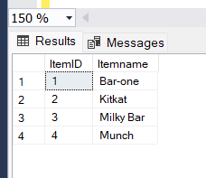

CREATE TABLE Shops(

ShopId INT PRIMARY KEY,

ShopName varchar(30)

);

INSERT INTO Shops VALUES

(1,'Amal Stores'),(2,'Jyothi Stores'),(3,'Indira Stores');

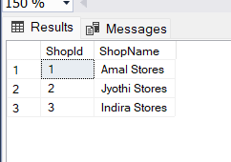

CREATE TABLE Prices(

ItemId int PRIMARY KEY

CONSTRAINT FK_70 FOREIGN KEY (ItemId) REFERENCES Items(ItemId),

Price INT);

INSERT INTO Prices VALUES

(1,10),(2,15),(3,5),(4,10);

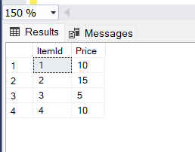

CREATE TABLE Units(

UnitPiece INT PRIMARY KEY,

UnitName varchar(30));

INSERT INTO Units VALUES

(1,'Piece'),(28,'Box Pack');

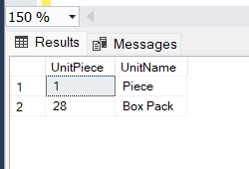

CREATE TABLE Chocolates(

OrderID INT IDENTITY PRIMARY KEY,

ShopId INT,

CONSTRAINT FK_sh FOREIGN KEY (ShopId) REFERENCES Shops(ShopId),

ItemID INT,

CONSTRAINT FK_it FOREIGN KEY (ItemId) REFERENCES Items(ItemId),

Qty INT,

Salesdate DATE,

Unitpiece INT,

CONSTRAINT FK_un FOREIGN KEY (UnitPiece) REFERENCES Units(UnitPiece)

);

INSERT INTO Chocolates VALUES

(1,1,100,'2018-10-05',1),

(1,2,200,'2018-10-05',1),

(1,3,50,'2018-10-05',1),

(1,4,150,'2018-10-05',1),

(2,1,10,'2018-10-10',28),

(2,2,30,'2018-10-10',28),

(2,3,40,'2018-10-10',28),

(2,4,20,'2018-10-10',28),

(3,1,50,'2018-10-15',28),

(3,2,70,'2018-10-15',28),

(3,3,30,'2018-10-10',28),

(1,1,150,'2018-10-15',1),

(1,2,250,'2018-10-15',1),

(1,4,100,'2018-10-10',1);

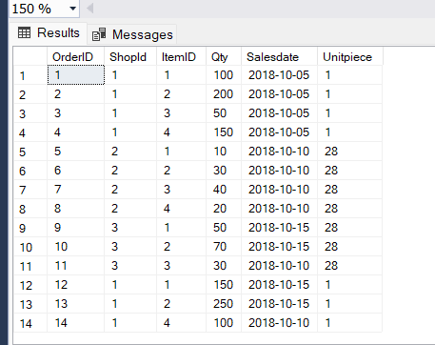

--Q1.2

SELECT top 1 i.ItemName,SUM(c.Qty*c.Unitpiece*p.price) AS 'Revenue'

FROM Items i

INNER JOIN Chocolates c

ON i.ItemID=c.ItemID

INNER JOIN Prices p

ON i.ItemID=p.ItemId

WHERE MONTH(Salesdate)=10

GROUP BY I.Itemname ORDER BY Revenue DESC ;

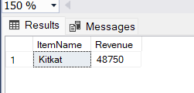

--Q1.3

SELECT TOP 1 i.ItemName,SUM(c.Qty*c.Unitpiece) AS TotalQuantity

FROM Items i

INNER JOIN Chocolates c

ON i.ItemID=c.ItemID

INNER JOIN Shops S

ON s.Shopid=c.Shopid

WHERE s.Shopname='Amal Stores'

GROUP BY i.Itemname ORDER BY TotalQuantity DESC;

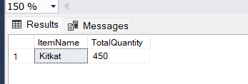

--Q1.4

SELECT i.ItemName,SUM(c.Qty*c.Unitpiece*p.price) AS Revenue from Items i

INNER JOIN Chocolates c

ON i.ItemID=c.ItemID

INNER JOIN Prices p

ON i.ItemID=p.ItemId

WHERE month(c.Salesdate)=10

GROUP BY i.Itemname

HAVING SUM(c.Qty*c.Unitpiece*p.price)>10000

ORDER BY Revenue desc;

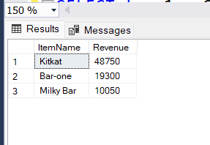

--Q1.5

SELECT top 1 s.ShopName, SUM(c.Qty* c. Unitpiece*p.price) as REVENUE

FROM Shops s

INNER JOIN Chocolates c

ON s.ShopId=c.ShopId

INNER JOIN Prices p

ON c.ItemID=p.ItemId

WHERE MONTH(c.Salesdate)=10

GROUP BY s.ShopName

ORDER BY REVENUE DESC;

